Velocity Based Training
  - Hype or Future

The foundation
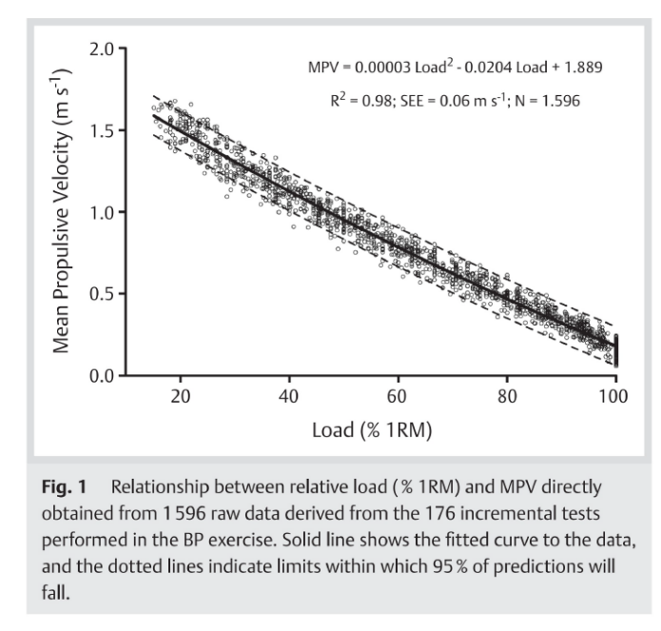
Velocity-Based Training is grounded in the methodology of performing every concentric repetition with maximal intentional speed. Central to this is the near-linear inverse relationship between the maximal velocity achievable on a lift and its relative load expressed as percentage of the one repetition maximum (1RM) [1].
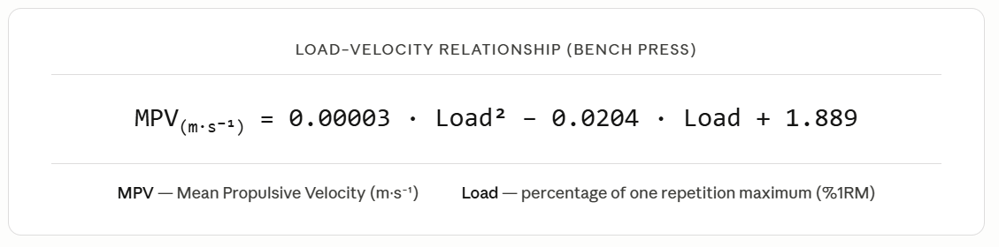As intensity increases, peak velocity decreases predictably, a relationship stable enough to work backwards from. By recording the velocity of a single repetition at a known load, you can accurately estimate an athlete's current one repetition maximum without ever lifting to failure [1].
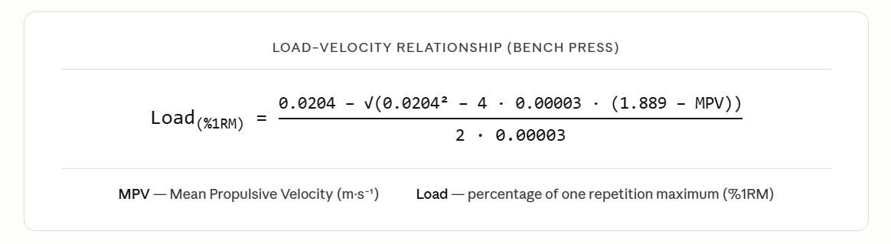
The 1RM is by nature a dynamic value, shifting over time through genuine strength progression or simple daily variation in readiness. This is precisely what makes velocity-based estimation so valuable. Rather than treating the 1RM as a fixed reference point tested periodically, it can be tracked continuously and adjusted to reflect the athlete's actual capacity on any given day, making load prescription both more accurate and more responsive.

It should be noted however that load-velocity profiles differ meaningfully between exercises and between the device and method used to obtain the data. To a lesser extent they also differ between athletes. This makes exercise-specific and device-specific profiles essential, and individual calibration strongly advisable.

Fatigue Detection
Beyond simple 1RM estimation, the use cases of tracking velocity extend far further. Within a set, as fatigue accumulates with each repetition, the achievable velocity on that lift progressively declines [2].
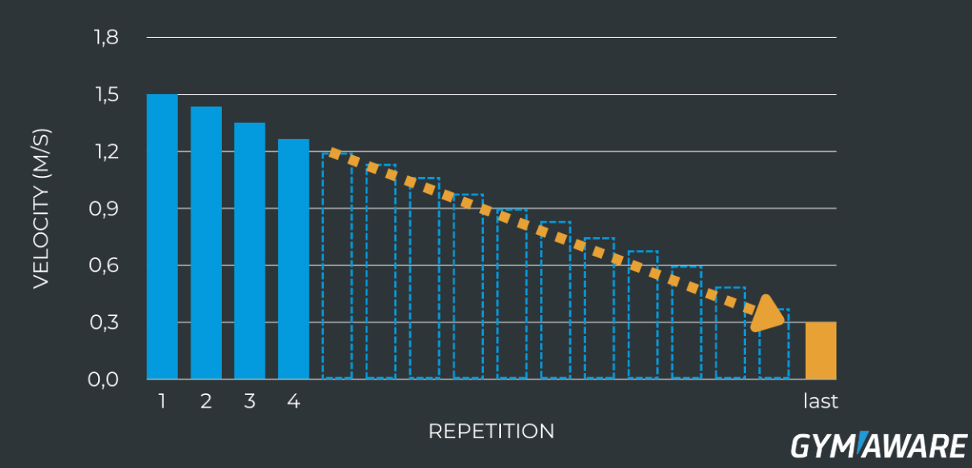
Traditionally, proximity to muscular failure has been expressed through Reps in Reserve (RIR), the athlete’s estimate of how many more repetitions could have been completed before failure. The concept is intuitive, but its reliability is inherently limited. Research consistently shows that athletes dramatically underestimate proximity to muscular failure, especially when far away from it. Reps in Reserve is a perception, and perception drifts [3].
Velocity loss cuts through that subjectivity entirely. By comparing the velocity of each repetition against the first and freshest rep of the set, you get a continuous objective readout of cumulative fatigue [2].
Beyond that, real time velocity tracking allows the athlete to terminate the set at a precisely defined velocity loss threshold. To illustrate, consider an athlete training with a 20% velocity loss threshold. If their first repetition is recorded at 0.80 m/s, the set is stopped the moment velocity drops to 0.64 m/s, regardless of how the athlete feels.

Scientific Justification
Research into velocity-based training is growing rapidly, and the emerging findings paint a promising but nuanced picture.
One the on hand a systematic review and meta-analysis by Orange et al. found only trivial differences in strength, power, and sprint speed between velocity-based and traditional training methods. On the surface this appears damning. However the studies included were primarily testing whether velocity-guided load prescription outperforms traditional methods, a narrow application that misses the full potential.
The more meaningful question is whether the complete velocity-based training framework is superior to traditional methods. This means looking beyond simple load prescription and examining what intentional fatigue regulation through velocity loss thresholds actually does to the adaptations produced.
The evidence for velocity threshold-dependent adaptation is compelling. Pareja-Blanco et al. compared two groups training at identical relative loads in the squat, differing only in permitted velocity loss per set, 20% versus 40%. Despite performing 40% fewer repetitions, the lower threshold group achieved equivalent strength gains and significantly greater countermovement jump improvements. More importantly, the higher threshold group showed a significant reduction in myosin heavy chain IIX content, the fastest and most powerful muscle fiber type, while the lower threshold group preserved it entirely. This fast-to-slow phenotypic shift offers a direct biological explanation for why excessive velocity loss compromises explosive performance. These findings were subsequently replicated in professional soccer players training in-season, where a 15% velocity loss threshold produced superior strength and jump improvements compared to 30%, despite the higher threshold group performing 65% more total repetitions.
The broadest synthesis of this evidence comes from Jukic et al., a systematic review and meta-analysis of 37 studies and 735 participants. Strength gains were largely similar across thresholds, though effect sizes consistently favoured low to moderate ranges. Hypertrophy increased near-linearly with velocity loss, driven primarily by the greater volume higher thresholds produce. For jumping, sprinting, and velocity against submaximal loads, a clear inverse relationship emerged as velocity loss increased, performance gains decreased. Higher thresholds additionally risk reducing rate of force development and prolonging recovery, compounding the interference with explosive capacity identified at the fiber type level.
As a result what the evidence suggests is that avoiding high levels of intra-set fatigue during phases where speed and explosive capacity need to be developed or preserved is likely beneficial for athletic performance. The velocity-based training framework, through its ability to quantify and regulate fatigue in real time via velocity loss thresholds, offers practitioners a more precise and objective way to achieve this than traditional training methods allow.

Application Potential
Translating the theoretical foundations of velocity-based training into practice reveals three concrete applications for strength and conditioning:
- Load prescription: By performing a single repetition against a submaximal load at the start of each session, the athlete's current one repetition maximum can be estimated and the training load adjusted accordingly. This ensures prescription reflects actual capacity on that day rather than a value that may be weeks out of date.
- Monitoring: By tracking velocity during both the daily load prescription and the working sets over time, practitioners gain a continuous and objective diagnostic tool. Reductions in velocity may indicate accumulated fatigue or overreaching, while increases reflect genuine strength adaptation.
- Fatigue Management: Velocity loss thresholds can be strategically adjusted across the training week and throughout the season to control fatigue accumulation. Larger thresholds (30%) are applied during high load training days to drive greater physiological and structural adaptations. Smaller thresholds (10%) are preserved during tapering sessions, closer to competition, to minimise neuromuscular fatigue while maintaining power output and performance.
The overarching value of this approach lies in its objectivity and can be further improved by individualisation. When velocity data is interpreted in the context of an athlete's own historical values and a personalised load-velocity profile, prescription becomes both more precise and more responsive, reducing the guesswork that inevitably accompanies traditional methods [7].

Modality Evaluation
The practical utility of velocity-based training depends entirely on the accuracy of the device used to capture it. Across four commercially available categories, the evidence reveals meaningful differences that directly determine how each can be applied.
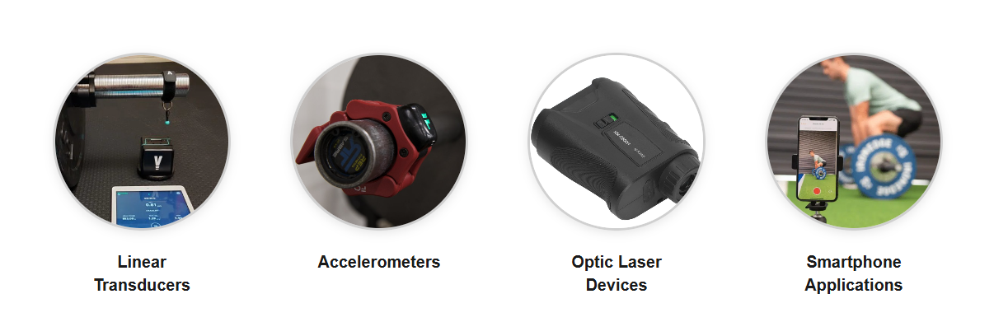
- Linear Transducers: Linear transducers represent the current gold standard, consistently demonstrating the highest accuracy and reproducibility across the available literature. They are appropriate for all core VBT applications, including load prescription, longitudinal monitoring, and precise fatigue regulation through velocity loss thresholds.
- Accelerometers: Wearable accelerometer devices offer portability and low cost, but their accuracy is consistently questionable, with error increasing substantially at higher intensities. Their use is best confined to motivational feedback during high-velocity exercises rather than any application requiring precise velocity measurement.
- Optic Laser Devices: Optic laser devices represent a promising and cost-effective intermediate, demonstrating acceptable validity across a broad range of loads in commonly used exercises. They offer a credible alternative to linear transducers for most practical applications, though research across a wider range of exercises remains limited.
- Smartphone Applications: Smartphone applications offer the lowest barrier to entry and can show reasonable validity when a single operator uses the same device consistently. However, substantial error emerges when devices or users change, limiting their use in team settings and high-precision applications.
The choice of device is not a peripheral consideration but a foundational one. The more precise and consequential the application, the greater the demand on device accuracy, and practitioners should select technology that matches the rigour of the training decisions being made from it [8].

Conclusion
Velocity-based training is not a tool for every context. Its value rests on a single non-negotiable condition where every repetition must be performed with maximal speed, which makes it most naturally suited to athletes for whom explosive output is not a training cue but a competitive reality. When that condition is met, it delivers a genuine upgrade to how load is prescribed, fatigue is managed, and adaptation is monitored.
So is it hype or is it the future? The honest answer is both, depending entirely on how it is implemented. The science underlying load-velocity profiling and fatigue regulation is compelling, but outcome evidence remains cautious and the field is still maturing. What separates meaningful application from expensive guesswork is the accuracy of the device in use. The less precise the measurement, the more carefully results must be interpreted, favouring trend analysis over individual data points. Practical adjustments such as averaging the first two repetitions of a set can furthermore help reduce the influence of measurement error on velocity loss calculations.
When adopted thoughtfully with technology matched to the demands of the application, individualised profiling per exercise and athlete, and an honest read of what the current evidence does and does not support, velocity-based training offers something traditional methods cannot. It provides a continuous, objective and honest picture of what the athlete is actually capable of on any given day.

Open Access Project

References
- González-Badillo JJ, Sánchez-Medina L. Movement velocity as a measure of loading intensity in resistance training. Int J Sports Med. 2010;31(5):347-52.
- Sánchez-Medina L, González-Badillo JJ. Velocity loss as an indicator of neuromuscular fatigue during resistance training. Med Sci Sports Exerc. 2011;43(9):1725-34.
- Halperin I, Malleron T, Har-Nir I, Androulakis-Korakakis P, Wolf M, Fisher J, Steele J. Accuracy in predicting repetitions to task failure in resistance exercise: a scoping review and exploratory meta-analysis. Sports Med. 2022;52(2):377–90.
- Pareja-Blanco F, Rodríguez-Rosell D, Sánchez-Medina L, Sanchis-Moysi J, Dorado C, Mora-Custodio R, et al. Effects of velocity loss during resistance training on athletic performance, strength gains and muscle adaptations. Scand J Med Sci Sports. 2017;27(7):724-35.
- Pareja-Blanco F, Sánchez-Medina L, Suárez-Arrones L, González-Badillo JJ. Effects of velocity loss during resistance training on performance in professional soccer players. Int J Sports Physiol Perform. 2017;12(4):512–9.
- Orange ST, Hritz A, Pearson L, Jeffries O, Jones TW, Steele J. Comparison of the effects of velocity-based vs. traditional resistance training methods on adaptations in strength, power, and sprint speed: a systematic review, meta-analysis, and quality of evidence appraisal. J Sports Sci. 2022;40(11):1220–34.
- Weakley J, Mann B, Banyard H, McLaren S, Scott T, Garcia-Ramos A. Velocity-based training: from theory to application. Strength Cond J. 2021;43(2):31–49.
- Weakley J, Morrison M, García-Ramos A, Johnston R, James L, Cole MH. The validity and reliability of commercially available resistance training monitoring devices: a systematic review. Sports Med. 2021;51(3):443–502.

